Pipeline runs-Databricks

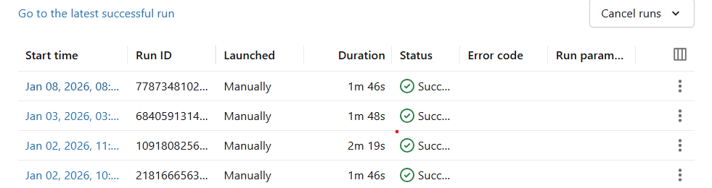

Deply and run pipeline
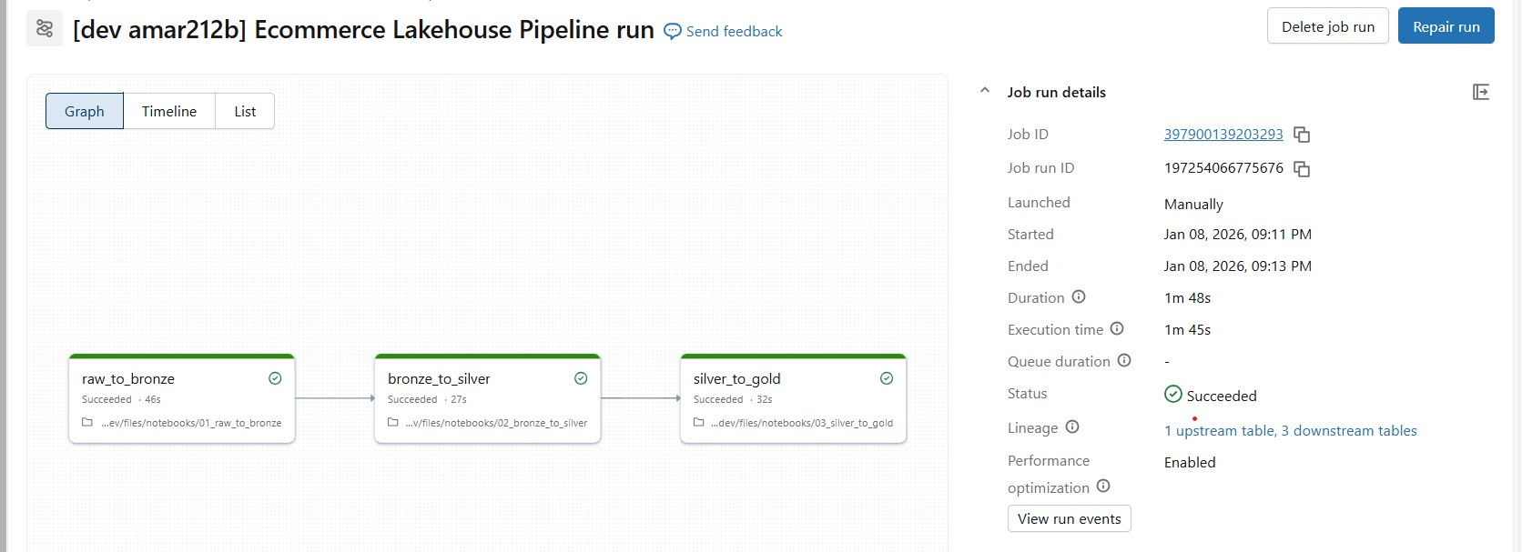

Github
